|  |  |
| --- | --- |
| Dublin bus  A Usability Design Investigation | Keith Feeney  15015556  BSHC4 – Software Development  2018/9 |

Contents

Introduction 3

Overview 3

Competitors 4

Go-Ahead Ireland 4

Transport for London 4

Google Play Store Apps 5

Primary needs & objectives 6

Primary needs of Dublin Bus 6

Vision 6

Mission 6

Values 6

Objectives 6

Strategy 7

Primary needs of the Dublin Bus website and app 7

Provide route information 7

Provide news and travel updates 8

Save most-used stops 8

Scenarios 8

Amy Sands – Planning a route 8

Jeremy Williamson – Calculating a fare 9

Site design and navigation 9

Sitemap 9

Sitemap of Dublin Bus 10

Design 10

Navigation 11

Mobile app 13

Functionality 13

Heuristics 13

Visibility of system status 13

Match between system and the real world 14

User control and freedom 14

Consistency and standards 14

Aesthetic and minimalist design 14

Help users recognise, diagnose, and recover from errors 14

Recommendations 14

Conclusion 15

References 16

# Introduction

This report will look at the Dublin Bus website and app from a usability design point of view. In this report, we will be looking at the Android app instead of the iTunes app. But both apps are very similar. It will look at the overview of Dublin Bus and its website competitors, such as Go-Ahead Ireland and Transport for London.

We will also look at the primary needs and objectives of Dublin Bus, the company, website and app. After this, the design and navigation of the Dublin Bus website and app will be discussed. Finally, we will evaluate the Dublin Bus website by means of heuristics and provide recommendations.

# Overview

Dublin Bus is one of the main public bus transport operators in Dublin. Dublin Bus is a subsidiary of Córas Iompair Éireann Group (CIÉ) and was established in 1987. In 2018, 139 million people used public transport with Dublin Bus. Dublin Bus has just under 3,500 staff, with 72% of its staff being drivers. (Dublin Bus, 2019)

Inclusive of its public transportation service, Dublin Bus also provides an Airlink service where buses travel from Dublin Airport to Dublin City directly. Another service Dublin Bus provides is Nitelink which operates from midnight to 4am on selected days and helps night owls return home. (Dublin Bus, 2019)

Dublin Bus has a fleet of just over 1,000 buses across its 7 garages, with all of its busses having a low-floor, for people requiring accessibility or for parents with buggies. In all its buses, Dublin Bus provides free Wi-Fi which provided by FleetConnect. (Dublin Bus, 2019) (Robertson, 2019)

Dublin Bus’s website was first launched in 1999 (Internet Archive, 2019) and has changed a lot in 20 years. The website itself today seems colourful to match the company logo and directly goes to real time information. The site is easy to navigate through.

Dublin Bus also has an app. Unfortunately, in late 2018, the Dublin Bus app on the Google Play Store has been removed for unknown reasons, but is available from other sources. The app is also colourful to match to logo and website and is also very easy to navigate though. The addition of Favourites (stored stops) in a nice added feature.

# Competitors

## Go-Ahead Ireland

In 2018, Dublin Bus was privatised. (Irish Examiner, 2018) The routes that buses operate in Ireland are owned by the National Transport Authority (NTA). As an indirect result of this privatisation, 24 Dublin Bus routes were put to tender and a contract for these routes was awarded to Go-Ahead Ireland. (Hosford, 2018) Go-Ahead Ireland is the biggest competitor for Dublin Bus. Go-Ahead Ireland is a subsidiary of Go-Ahead Group which began operating in 1987 when the UK’s National Bus Company was privatised. (Go-Ahead Group, 2019)

The Go-Ahead Ireland’s website is quite limited. There is no real time information is on this site. Nevertheless, this information can be found on the NTA’s Transport for Ireland’s (TFI) website instead. The Go-Ahead Ireland website looks colourful and is easy to read and navigate through. The website has news, contact information, route information, timetables, and the like. A good feature that is included is that there is a “things to do” section. That seems like a nice, well thought-out touch. The site feels all new and shiny. It can be imagined the smell of plasterboard on its Internet wires is still setting.

## Transport for London

In the UK, Transport for London is similar to the NTA who run TFI, but Transport for London only serves London, as the name would suggest. In relation to bus services, the contract for operating London buses is mostly managed by London Bus Services Limited which is a subsidiary of Transport for London. (Transport for London, 2019) Some of the other services Transport for London manages are coaches, cycling rentals, London Underground, trams, cable cars, river passenger routes, taxis and rail services. (Transport for London, 2019)

In comparison with the Dublin Bus website, the Transport for London website seems very reliable. On the main page, there is information on areas, lines or routes that are having issues. It doesn’t seem cluttered either, even with the amount of information. This is a positive. When searching for routes from and to a location, it’s extremely simple. All one needs are literally the origin and destination and that’s it. But with the Dublin Bus website and app, one would need to know the bus route or the stop number to figure out what bus should be taken.

With the Transport for London site, the results show what type of transport one could take, whether it be bus, rail, or cycling for example. It’s also a nice feature that the price is automatically available. One can see exactly how much the transport will cost for that particular time (e.g. off-peak) or another time of the day. The cycling route also shows how tough the route is. When using the origin of “Westminster” and destination of “Abbey Road”, the cycling route was “moderate”. Overall, the website is up-to-date, fresh and very easy to navigate through. While the website caters for planning a journey, it seems that looking for real time information about one route would be cumbersome.

## Google Play Store Apps

The first 8 results on the Google Play Store with the search term “Dublin Bus” results in apps that are called “Dublin Bus: Real Time Info” or an alteration of that name. (Google, 2019) The official Dublin Bus app is not listed, as mentioned above. Within the first 8 apps, the apps all offer something similar and include; real time information from stops that Dublin Bus operate on, Dublin Bus routes, ability to add favourites, route maps, alerts and news from Dublin Bus.

One of these apps really stands out from the others, Dublin Bus Buddy. The app is awful. Very little colour in the app, if any, and it is all text based. No maps. The design in just very unappealing. It’s not enticing or creates a want to use it. As we later find out, the Dublin Bus app is not perfect, but it would be better to use that than Dublin Bus Buddy.

Seemingly, the best app of these 8 is “Dublin Bus: Next Bus Dublin Free”. There is a street view for the selected stop, as well as alerts, route maps. It also is compatible with smart watches running Android. It’s also very colourful and with the positive reviews, people seem to like this one.

# Primary needs & objectives

## Primary needs of Dublin Bus

* Vision
* Mission
* Values
* Objectives
* Strategy

### Vision

This is where Dublin Bus is to provide a transport service where people feel safe, connected and part of community life in Dublin, linked with each other and part of the community in Dublin. (Dublin Bus, 2019)

### Mission

Dublin Bus is wanting to increase their customers’ interaction and numbers and where all and each customer journey is valuable. (Dublin Bus, 2019)

### Values

Dublin Bus is to ensure safety at all times and to ensure that every interaction their customers and staff have is done with safety in mind. Dublin Bus wants to improve their customer’s interactions and to understand that people are all different and not to be bias towards a particular person or background. Dublin Bus would like to think they are enhancing communities and bringing people together. (Dublin Bus, 2019)

### Objectives

Dublin Bus is to run the business in an applicable way that increases revenue and outdoing their current goals. Dublin Bus is to generate funds by focusing on customer happiness. Dublin Bus is to appreciate new technological advances and increases their customer base, safety practices and to better how they work. Dublin Bus is to be dedicated to interact with stakeholders, to better and generate customers in a way that is deemed appropriate. (Dublin Bus, 2019)

### Strategy

Dublin Bus is to communicate how public transport is better, but meeting with stakeholders on a regular basis. Dublin Bus is to assist in traffic clogging by initiating new stop services. Dublin Bus is to use instruments to help employees in different areas share their brain power and formulate new business thoughts and assisting in fixing obstructions. Dublin Bus is to help to enhance in people using public transport by being devoted to customers.

## Primary needs of the Dublin Bus website and app

* Provide route information
  + Real time information
  + Timetables
  + Route Planner
  + Calculate a fare
  + Events
* Provide news and travel updates
* Save most used routes (App only)

### Provide route information

#### Real time information

Dublin Bus is to provide real time information of its routes and by bus stops it uses. A customer can also look up the address of a bus stop location to get the required information.

#### Timetables

Dublin Bus is to provide timetable information of the routes it operates. A customer can look up this information by either the route number or place name.

#### Route Planner

Dublin Bus is to provide a route planner where a customer can input an origin and destination and get the most direct route to their destination.

#### Calculate a fare

Dublin Bus is to provide a way for a customer to calculate their fare. A customer will need the bus route, the direction of the route, the stop they’re boarding the bus at and the stop the customer is departing at.

#### Events

Dublin Bus is to provide customers with how to get to events in Dublin or surrounding areas, while using Dublin Bus to get to said event.

### Provide news and travel updates

Dublin Bus is to provide news, such as diversions, stop relocations, route alterations and other general information about Dublin Bus and its services.

### Save most-used stops

Within the Dublin Bus app, a customer is to be able to save particular stops as a “Favourite” for ease of access in the app.

## Scenarios

### Amy Sands – Planning a route

Amy Sands uses Dublin Bus services every day from Monday to Saturday. She lives in Coolock and works near Eden Quay. She usually gets the 15 bus to and from work. On Saturdays, she uses Dublin Bus to travel to the city for a Saturday night out. Amy’s friend, Lisa, lives in Tallaght. Lisa just phoned Amy to say she slipped on some ice, fractured her arm and was taken to Tallaght University Hospital. Amy is concerned about Lisa and wants to go and see her at the hospital, but doesn’t know how to get there.

Amy looks at the Dublin Bus website and looks at the route planner. She inputs where she is now in the origin field and puts in “Tallaght Hospital” in the destination field. Amy figures out she will need to take the 15 to Eden Quay and then the 27 to Belgard Road / Tallaght University Hospital.

### Jeremy Williamson – Calculating a fare

Jeremy has just landed at Dublin Airport and wants to go home to Glencullen. Jeremy has a Leap Card. Jeremy goes onto the Dublin Bus app and taps on the menu icon and selects “Fare Calculator”. Jeremy decides to get the 747 Airlink bus to Connolly Station, then the 14 bus to Dundrum Luas and then the 44B to Glencullen.

For each of these bus routes, Jeremy inputs the route, origin and destination. On the app, it shows that the 747 bus will cost Jeremy €7.00, the 14 bus will cost €2.50 and the 44B will cost Jeremy €2.25. This totals to €11.75 for his trip. If Jeremy had gotten the 16 bus instead of the 747 bus, he would have been capped at €7.00 on his Leap Card, saving him €4.25.

# Site design and navigation

## Sitemap

A sitemap (or site map), as the name suggests, is a mapping of a website. It’s useful for the likes of visitors to the website and also to search engines. A sitemap of a website can be a standard HTML formatted page with links, possibly put into categories or could also be an XML document, which would be more useful for crawl bots with search engines. (Hallissey, 2017)

### Sitemap of Dublin Bus

(Feeney & HotGloo, 2019)

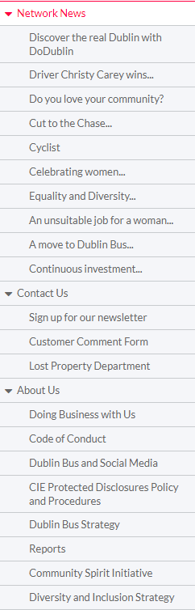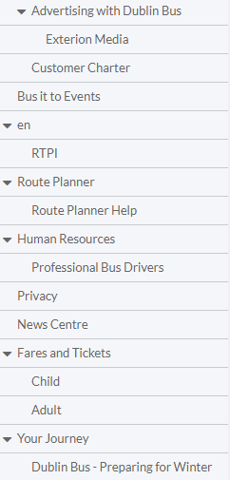

## Design

After looking up dublinbus.ie in Web Archive (<https://web.archive.org/>), the last Dublin Bus website redesign was in 2011. The only other change was that the route and journey search options above the fold were replaced in 2014 with searching by stop number, route or stop address.   
  
In comparison with similar websites such as Transport for London and Go-Ahead Ireland, it seems likes Dublin Bus has no intention or want to update their website. The saying “Don’t fix things that aren’t broken” comes to mind, but the Dublin Bus website is 8 years old in its current format. It might as well be part of the antediluvian times, regarding how fresh and updated the Internet and its information is.

Even though the information is there and it’s easy enough to navigate through, the website seems tired and if given another alternative like the NTA’s TFI website, TFI would win. With real time information having become more normalised and expected, Dublin Bus have a link to say what it is on the main page. Is that necessary todsy? It’s very doubtful. For a major company, the website seems rather simplistic as if an intern produced it on their own. It needs some considerable updating.

## Navigation

With the example of Transport for London’s website, main parts of what a customer or visitor would need are on the main page, with additional information one or two clicks away. One can see what routes are having service disruptions for whatever reason, news or events, for example. Dublin Bus’s website is not like that. Above the fold on the main page is a search by bus route, stop number, or stop address with news and a few other text links.

Dublin Bus – Home Page:

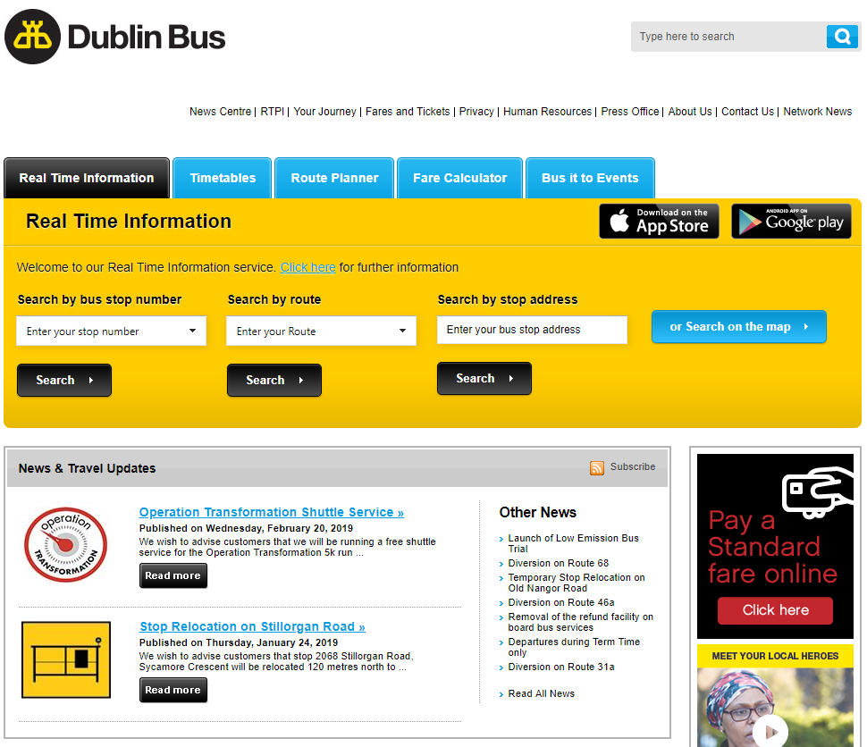 (Dublin Bus, 2019)

Transport for London – Home Page:

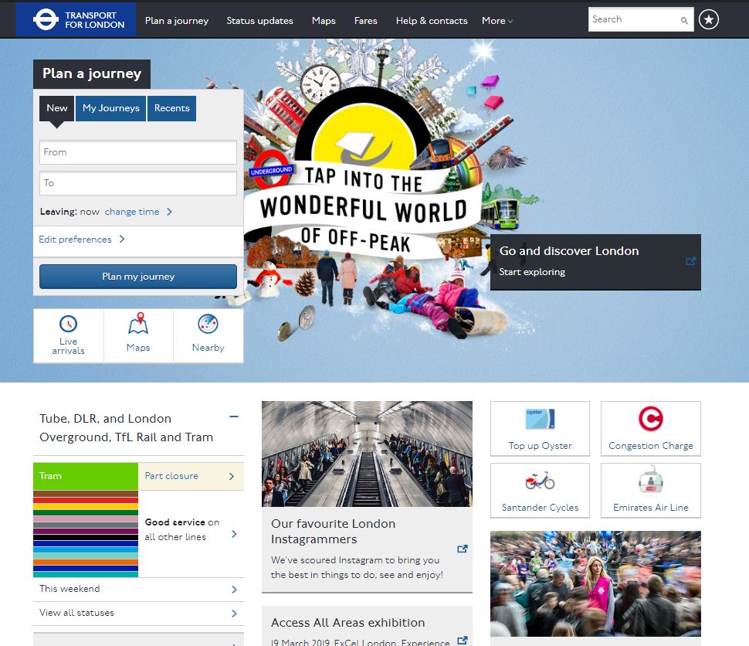 (Transport for London, 2019)

One can simply see that even though there’s more content on the Transport for London website, it just seems fresher and up-to-date. Its navigation is very simplistic too. However, with the Dunlin Bus website, its navigation is a bit all over the place. Is one meant to be following the small navigation bar on the top right or the secondary navigation bar with the blue background? It’s a little confusing.

## Mobile app

As of late 2018, the Google Play Store app has been removed for unknown reasons. It is possible to download the app unofficially. After opening the app, the user is presented with options, “Search by Stop Number”, “Search by Route”, “Search by Address”, “Stops Near Me”. The menu holds similar headings that are on the main page of the Dublin Bus website. A post on Facebook by Dublin Bus states that the latest version of the Google Play app was released in January 2013. (Facebook; Dublin Bus, 2013) Regarding the style of the app, it follows suit with the website and needs to be updated

## Functionality

If one wishes to use Dublin Bus’s website or app for their functionality, don’t. With routes being changed, removed or taken over by other companies, the functionality of Dublin Bus is outdated and somewhat broken.

# Heuristics

For this section, we will be using Jakob Nielson’s heuristic evaluation for the layouts of a user interface.[1]

## Visibility of system status

It is recommended that the user is aware of the progress of what they are doing and doing so inside an acceptable timeframe. (Nielsen, 1994) The Dublin doesn’t exactly do this. For example, when looking at a timetable for a route, if one didn’t know what a timetable was, they would be unclear where they were within the website, as the blue headings mentioned above do not change whatsoever. This is apparent across the website.

## Match between system and the real world

The user interface is supposed to use language that is appropriate to its users, such as “real-world conversations”, and what the user sees should match this. (Nielsen, 1994) The Dublin Bus website uses simple English in most parts of the website and there are a few local Dublin phrases that pop up occasionally in the news section.

## User control and freedom

Mistakes can be made by a user and they would require a quick way to exit what they’re doing. (Nielsen, 1994) The Dublin Bus logo directs the user to its home page. There is also a “You are here” line of text under the secondary navigation bar.

## Consistency and standards

Ambiguity is not a user’s friend. Information should be crystal clear. (Nielsen, 1994) The Dublin Bus website is good at avoiding ambiguity. There were no issues found in this regard.

## Aesthetic and minimalist design

Any information that is not relevant should be removed. Information should compliment the section. (Nielsen, 1994) The Dublin Bus website is a little too minimalist and clunky to use. A slight bit more information and clarity would be beneficial.

## Help users recognise, diagnose, and recover from errors

Short text containing what went wrong, i.e. the error, should be said in simple English, and provide a solution. (Nielsen, 1994) The Dublin Bus website does not have error prevention. For example; from the home page, if a user inserts nothing into the “Search by bus stop number” field and selects “Search”, the page just reloads with no message.

# Recommendations

* Update the website, taking inspiration from the likes of Transport for London and Go-Ahead Ireland.
* Have a feature where status updates about Dublin Bus and its routes are viewable directly from the home page.
* Correct and update the functionality of the website, as some features don’t work as expected.
* If cost is an issue, downgrade the website about Dublin Bus services, to be like Go-Ahead Ireland’s website, and use the NTA’s TFI website for routes, maps and real time information, for example.

# Conclusion

This repot examined the Dublin Bus website and app from a usability point of view. We discussed what Dublin Bus is and how Go-Ahead Ireland and Transport for London are examples of its website competitors.

It was also discussed what the primary needs and objectives of Dublin Bus as a company and as a website. The Dublin Bus website as scrutinised by means of heuristics evaluation. Recommendations of how the Dublin Bus website could be improved were also inspected.

# References

Cover image: Public domain.

Feeney, K & HotGloo, 2019, *Dublin Bus sitemap*, image, viewed 21 February 2019,  
< https://www.hotgloo.com >.

Dublin Bus, 2019, *Home – Dublin Bus*, image, viewed 22 February 2019,  
< http://dublinbus.ie >.

Transport for London, 2019, *Keep London moving – Transport for London*, image, viewed 22 February 2019,  
< https://tfl.gov.uk >.

Dublin Bus, 2019. *Corporate Information.* [Online]   
Available at: http://www.dublinbus.ie/About-Us/  
[Accessed 18 February 2019].

Dublin Bus, 2019. *Dublin Bus Strategy.* [Online]   
Available at: http://www.dublinbus.ie/About-Us/Dublin-Bus-Strategy1/  
[Accessed 18 February 2019].

Facebook; Dublin Bus, 2013. *Our new Android App....* [Online]   
Available at: https://www.facebook.com/DublinBusNews/posts/our-new-android-app-is-now-available-in-the-google-play-store-with-new-additions/557024047641223/  
[Accessed 22 February 2019].

Go-Ahead Group, 2019. *About us.* [Online]   
Available at: https://www.go-ahead.com/en/about-us.html  
[Accessed 18 February 2019].

Google, 2019. *Apps.* [Online]   
Available at: https://play.google.com/store/search?q=dublin+bus&c=apps  
[Accessed 18 February 2019].

Hallissey, T., 2017. *WHAT IS A SITEMAP, AND WHAT IS ITS PURPOSE IN WEB DESIGN?.* [Online]   
Available at: https://fatguymedia.com/web-design/what-is-a-sitemap/  
[Accessed 23 February 2019].

Hosford, P., 2018. *This is what buses will look like on 24 Dublin routes later this year.* [Online]   
Available at: https://www.thejournal.ie/new-dublin-bus-livery-go-ahead-4116874-Jul2018/  
[Accessed 18 February 2019].

Internet Archive, 2019. *Wayback Machine.* [Online]   
Available at: https://web.archive.org/web/19990501000000*/http://www.dublinbus.ie/  
[Accessed 18 February 2019].

Irish Examiner, 2018. *Privatisation of Dublin Bus routes 'the beginning of race to the bottom' TDs warn.* [Online]   
Available at: https://www.irishexaminer.com/breakingnews/ireland/privatisation-of-dublin-bus-routes-the-beginning-of-race-to-the-bottom-tds-warn-867983.html  
[Accessed 18 February 2019].

Nielsen, J., 1994. *10 Usability Heuristics for User Interface Design.* [Online]   
Available at: https://www.nngroup.com/articles/ten-usability-heuristics/  
[Accessed 23 February 2019].

Robertson, C., 2019. *Dublin Bus.* [Online]   
Available at: http://fleetconnect.ie/case-studies/dublin-bus/  
[Accessed 18 February 2019].

Transport for London, 2019. *Bus tender search.* [Online]   
Available at: https://tfl.gov.uk/forms/13923.aspx  
[Accessed 21 February 2019].

Transport for London, 2019. *What we do.* [Online]   
Available at: https://tfl.gov.uk/corporate/about-tfl/what-we-do  
[Accessed 21 February 2019].

1. The heading in the Heuristics section are from <https://www.nngroup.com/articles/ten-usability-heuristics/>. Only the most relevant headings were selected.